Devin Hardy

00076619

Dhardy2@my.athens.edu

1. Purpose of the website:

To provide a way to garner peoples attention and provide information about the restaurant.

Such information is what kind of food it has, where it is located, and brief overview of the menus it has such as the dinner churrascaria/rodizio, the lunch street food menu, and the afternoon plated mix of the churrascaria/rodizio and street food menu.

1. The stakeholders and the target audience:

Stakeholders: banks, colleagues, suppliers, customers

Target audience: Those who want to eat and enjoy Brasilian food.

1. Create a site map:

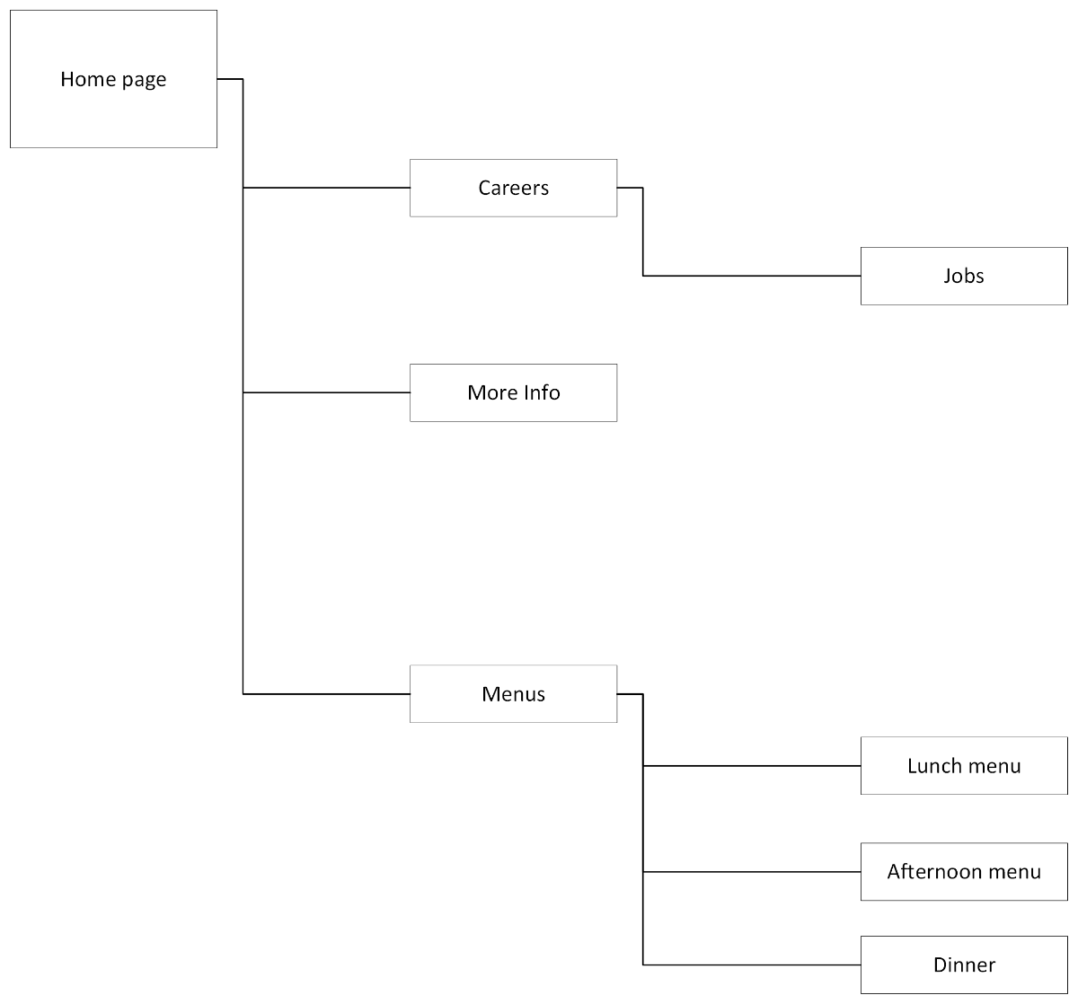

1. A wireframe: